Test Plan For Order History Enhancements(AUDIT Events)

Manual verification will run the following seven test cases using trader gui and verify the audit history events as specified in each test case. The CDB regular replication testing during the ATG test phase will verify the data.

Setup
It may be necessary to turn on the audit logging for the symbol you are working with. If the audit does not show up with detail as shown below, the first thing to do is turn on the audit logging with an AR command (it is off by default).

The audit logging is turned on by running the following AR command against the OHS Server process (the example turns it on for symbol ANF):

ar OHServerHybrid toggleAuditHistory -symbols ANF true

Test Case 1:

Enter a buy Customer Order and verify the Audit History events are created by querying the Order History details and selecting the “Display Audit Order History” check box). See the following screen shot. Usually for the Customer order we create (36 Audit History events).

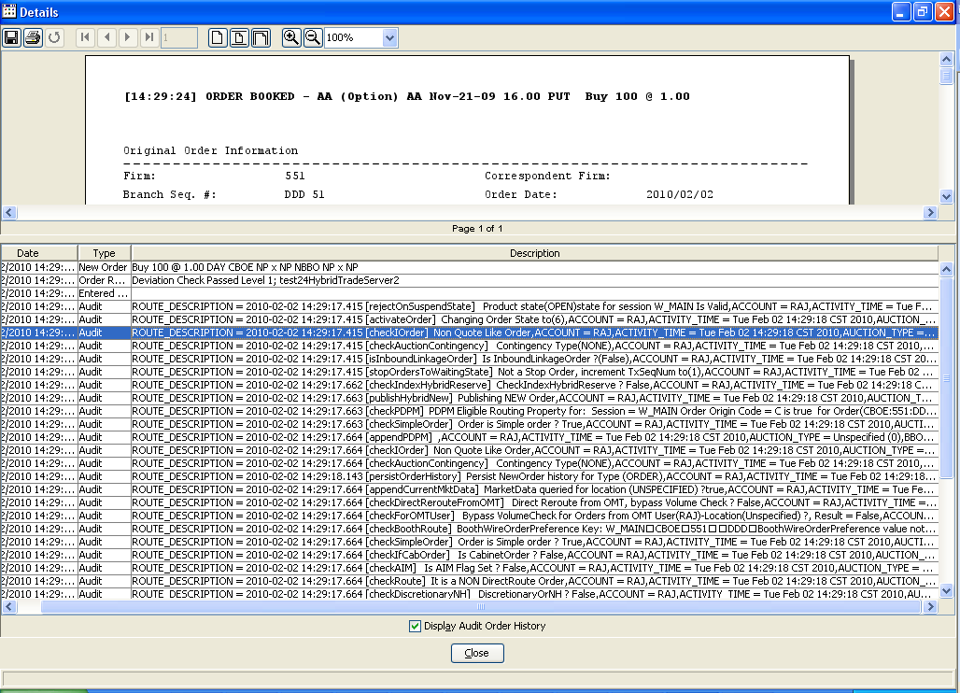

Test Case 2:

Enter a sell Market Maker (M origin type) Order and verify the Audit History events are created by querying the Order History details and selecting the “Display Audit Order History” check box). See the following screen shot.

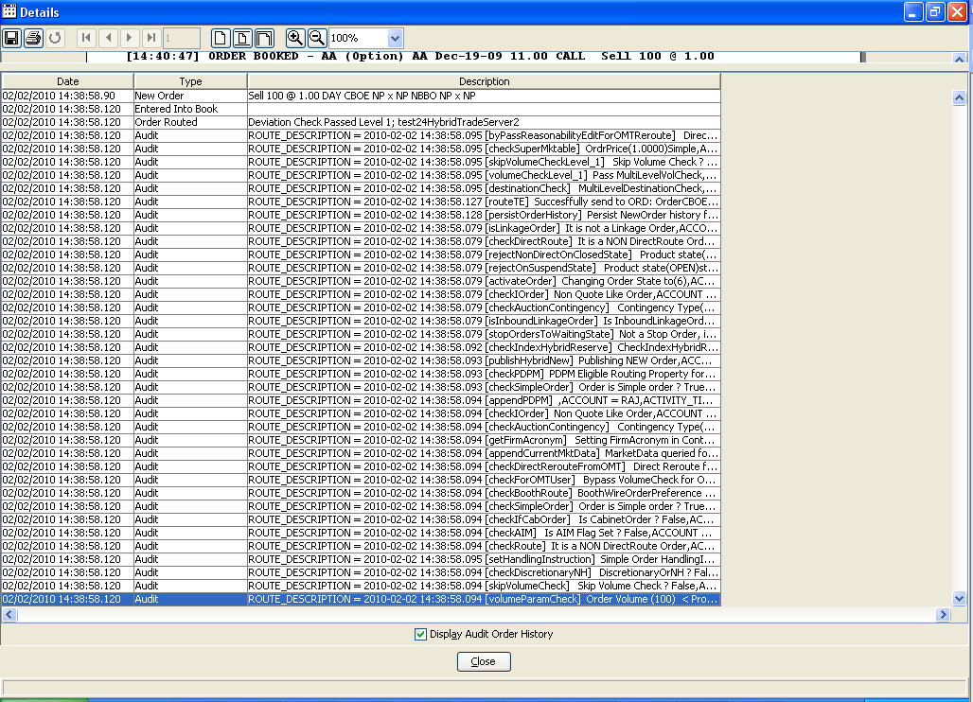

Test Case 3:

Enter a Buy Customer Order (C origin type) Order which fails the volume check and verify the Audit History events are created by querying the Order History details and selecting the “Display Audit Order History” check box). See the following screen shot.

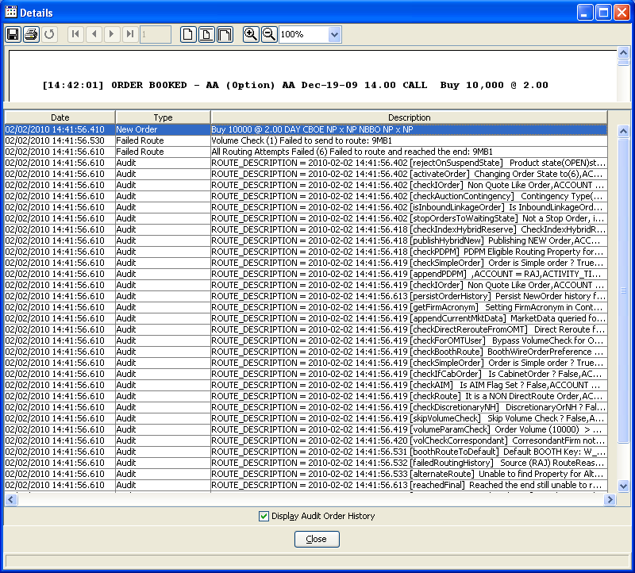

Test Case 4:

Enter a Strategy Order and verify the Audit History events are created by querying the Order History details and selecting the “Display Audit Order History” check box). See the following screen shot.

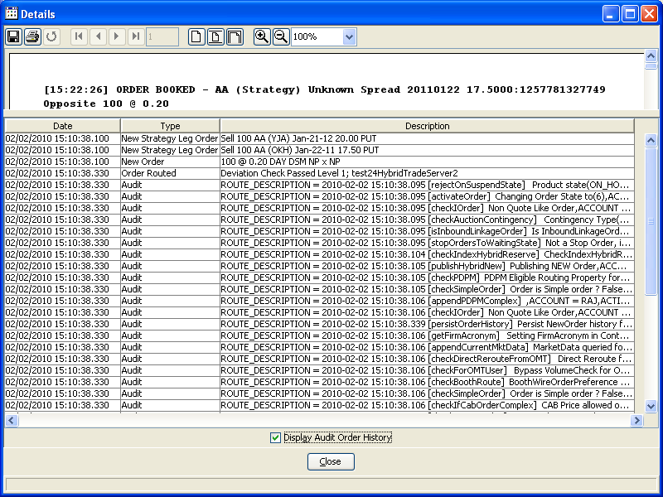

Test Case 5:

Enter a Buy/Write Order and verify the Audit History events are created by querying the Order History details and selecting the “Display Audit Order History” check box). See the following screen shot.

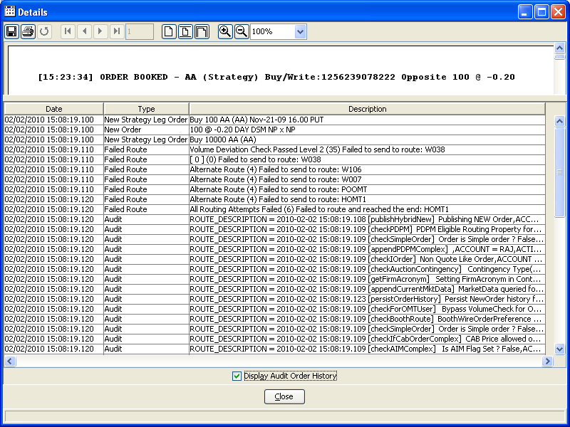

Test Case 6:

Cancel/replace a strategy Order and verify the Audit History events are created by querying the Order History details and selecting the “Display Audit Order History” check box). See the following screen shot.

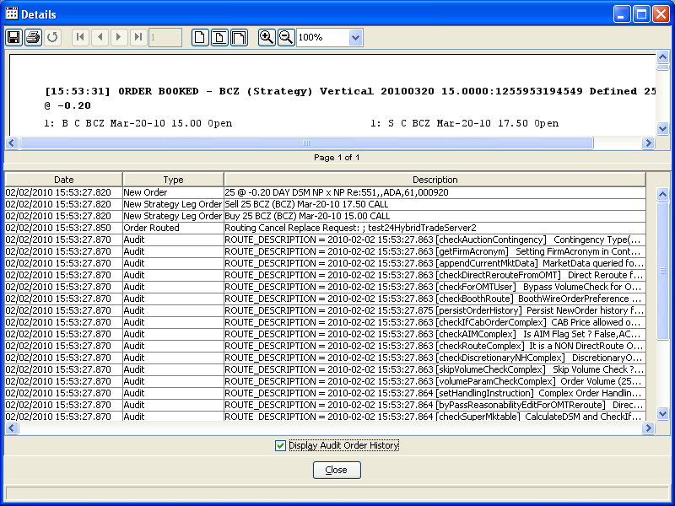

PS: The order for this test case should be resting in the Book.

Test Case7:

Enter a C-IOC (Express Order) and Verify no Audit History created by checking the order history (please select the check box for “Display Audit Order History”)

